**Spring 2017**

**ESI 5359**

**Industrial Financial Decisions**

**Yezehao Huai (5965823)**

**Chapter 10 Homework**

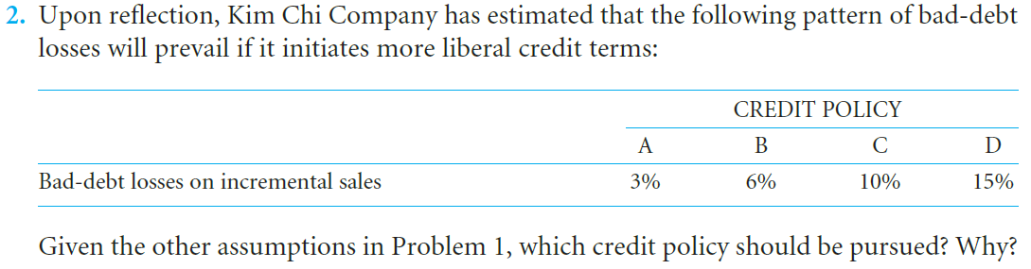

Contribution margin ratio = ($20-$18)/$20=10%.

Variable cost per unit/Sales price per unit= $18/20$ =0.90

Pre-tax opportunity cost of funds is 30 percent.

|  |  |  |  |  |
| --- | --- | --- | --- | --- |
| CREDIT POLICY | A | B | C | D |
| Increase in sales | $2,800,000 | $1,800,000 | $1,200,000 | $600,000 |
| Profitability of additional sales | $280,000 | $180,000 | $$120,000 | $60,000 |
| New receivable  turnover | 8 | 6 | 4 | 2.5 |
| Additional receivables | $350,000 | $300,000 | $300,000 | $240,000 |
| Investment in additional receivables | $315,000 | $270,000 | $270,000 | $216,000 |
| Additional bad-debt losses | $84,000 | $108,000 | $120,000 | $90,000 |
| Opportunity cost | $94,500 | $81,000 | $81,000 | $64,800 |
| Total costs | $178,500 | $189,000 | $201,000 | $154,800 |

Compare the total costs with profitability of additional sales, only in policy A the total costs $178,500< profitability of additional sales $280,000. So the policy A should be pursued.

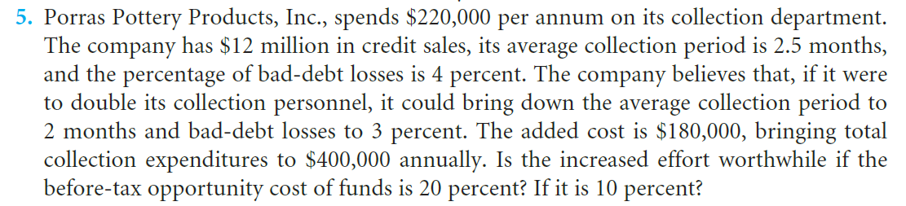

Annual sales is $12 million, present receivable turnover is 4.8, so the present receivable is $250,000,000.

The new receivable turnover is 6, so new the receivable is $2,000,000.

The reduction of receivable is $2,500,000-$2,000,000=$500,000

The present annual bad-debt loses is $12,000,000*4%=480,000, the new bad-debt loses is $12,000,000*3%=360,000, so the reduction in bad-debt loses is $120,000

At 20% opportunity cost, the return on reduction is $500,000*20%=$100,000, total reduction is $100,000+$120,000=$220,000>$180,000

At 10% opportunity cost, the return on reduction is $500,000*10%=$50,000, total reduction is $50,000+$120,000=$170,000<$180,000

To sum up, the total return on reduction in receivables at 20% opportunity cost is larger than the cost of double its collection personnel, so it is worthwhile. But if opportunity cost is 10%, not worthwhile.

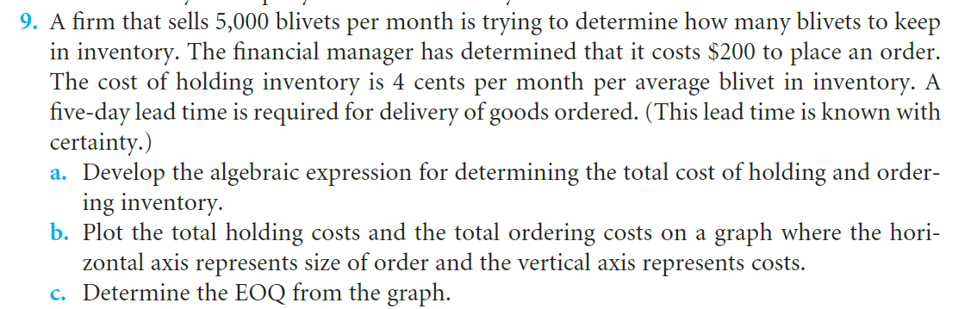

1. T= C(Q/2)+O(S/Q)

= $0.04(Q/2)+$200(5,000/Q)

**When C(Q/2)=O(S/Q), Q≈7000，the cost is the lowest**

|  |  |
| --- | --- |
| Q | Cost |
| 1000 | 1020 |
| 2000 | 540 |
| 3000 | 393.3333333 |
| 4000 | 330 |
| 5000 | 300 |
| 6000 | 286.6666667 |
| **7000** | **282.8571429** |
| 8000 | 285 |
| 9000 | 291.1111111 |
| 10000 | 300 |
| 11000 | 310.9090909 |
| 12000 | 323.3333333 |

1. From the graph EOQ is 7000,by calculate EOQ=√(2*200*5000)/0.04≈7071